New Permissions and Teams Design

Action Items

tasks
- Create Groups table, this table contains KeySchema: GroupID, UserID, Group Name
- Create UI to groups page by the Figma
- Add to permissions db the Action column with ManageAccess and ViewLogs
- Use these permissions… For example - let users with ViewLogs ViewLogs to view logs
- Start managing duplicate logs in the audit logs db (save log per parent in the breadcrumbs hierarchy)
- Review this: Permission Dilemmas

Questions for next time
- Is there a Link entity
- See people's logs? In this case the resource is a person or a group. Do you even need such an ability?
- Unsolved for us - how to access the file (protected, password, phone, email, mfa, etc...)
- CDR? DLP? Are these defined at the system kinfug level or at the permissions level?
- The SOC team adds permissions

Use-Cases to Supprot

Almond
- Casual users (recipients) - connect with a one-time code. The files are available for a short period of time.
- Registered users (recipients) - can log in with a username and password. Keep their files.
- Sub-insurers (senders) - verification by email, and without additional settings.
- Low priority: A file of type "audio" cannot be downloaded

NARDI
- IR_TEAM+119 - that’s a team that want to collaborate their work on files inside workspace (co-owner of a workspace)
  - View files on workspace
  - Manage permissions to all files on workspace
  - View logs of the workspace
- External users should be able to upload files to the Workspace
- Co-owners want to be able to upload files to this workspace
- We should have an easy way to expand the expiration time for the workspace
- 119+IR_TEAM - Work on a shared Workspace. Anyone with Workspace permissions from the IR team can:
  - See the files in Workspace.
  - Manage permissions of all files in Workspace.
  - View logs of all files in Workspace.
- Externals can add files to the same Workspace, but without the other permissions mentioned above
- Transferring files (investigation tools) to clients through the Workspace, then receiving findings through the same Workspace.
- Some investigations last longer than the expiration time initially set on the workspace, and a convenient way to estimate this duration is needed.

Complete INCD scenario
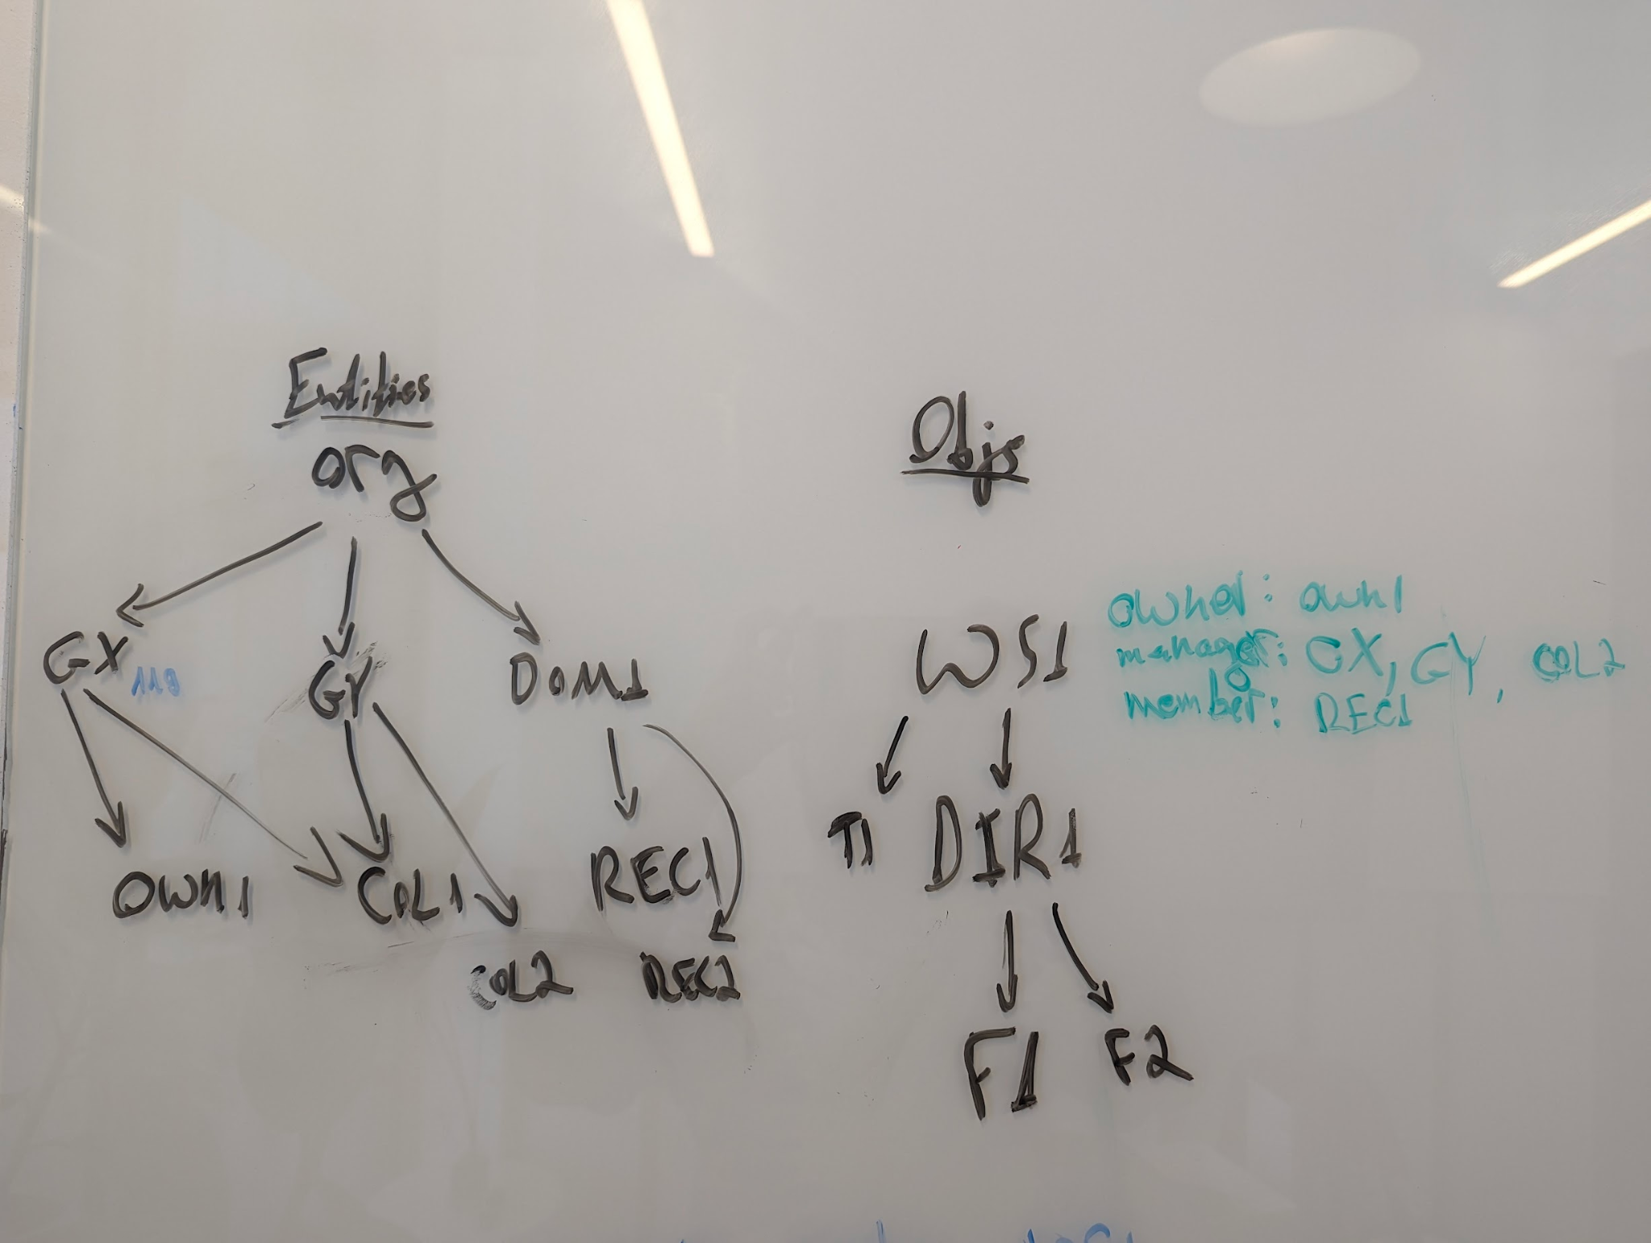
Permission levels:
  - Manager
    - Can view all Workspace logs
    - Can manage permissions for all files ב-Workspace
    - Will receive notifications about changes in the workspace
  - Member
    - Can view existing files in Workspace
  - Contributer
    - Can add files to Workspace

- OWN1 creates WS1 (a workspace)
- OWN1 uploads T1 (a file) to WS1
- OWN1 creates DIR1 (a folder) in WS1
- OWN1 shares WS1 with GX (a group) as Managers
- OWN1 shares WS1 with REC1 (a recipient) as a Member
- REC1 downloads T1
- REC1 uploads F1 to DIR1
- COL1 (a member of the GX group) downloads F1
- COL1 views logs for WS1
- COL1 shares WS1 with GY (another group) as Managers
- COL1 shares WS1 with REC2 (another recipient) as a Contributer
- REC2 uploads F2 (another file) to DIR1 (through a direct link)
- COL2andshares WS1 from GX
- COL2 downloads F2
- OWN1 views logs for WS1
- COL2 shared F2 with U1, U2, GX, and DOM1
- U1 downloaded the T1. RMS encryption was applied.
- COL2 opens T1 in SpecterX Reader

It hurts me
- The general constitution supports 14-day expiration and verification with a phone number.
- Defining a diplomatic constitution by departments.

REE
- to define a constitution according to the sending department. The IT department only needs a secure transfer of large files that allows transfer within the domain.
- The marketing department needs document protection.
- The CEO needs an open constitution that allows transfer to anyone.
- Recipient is a certain imaginary (million steps)

General
- Enforce a constitution according to the user's group
- In some cases allow the sender to choose between several possible constitutions where one is the default
- The minimum is always what was defined by the system, and the user can make it worse

Ronit’s Ideas
- Differentiate between singular / plural recipient
- Action: Revoke from any domain

Policies to Support
Mockup
- Recipients can share
- Automatically share with specific users
- Data expiration
  - Upon retention, permanently delete from My files
  - Days before retrieving remote copies
- Recipient Language
- Allow only specific users to use this policy
- Protect downloaded files
  - Prevent downloading unsupported files
- Require receival confirmation prior to download
- Require email verification
- Require phone verification
- Viewable only using the SpecterX viewer
  - Add watermark to PDF files
- Protect with password

Workspace/Folder permissions management:

 | Read  files | Download | Write | Add files | Manage permissions | Delete | Move | View logs
Viewer (currently for single files only) | V
Contributer (replaces ‘Editor’) | V | V | V | V
Manager | V | V | V | V | V | V | V
Co-owner | V | V | V | V | V | V | V | V
Owner | V | V | V | V | V | V | V | V

*Notifications for new files will be send as part of a sharing a new file with a user (doesn’t matter the user permissions)

Roles:
- Viewer (files only)
  - Can view content
- Editor / Contributor
  - Can add and edit content
- Member: Can see and access all the files in the Workspace, get notifications when there are files added, and everything a Contributor can do.
- Manager
  - Can add, edit, move, delete and share content
- Co-owner
  - Can add, edit, move, delete and share content, and read associated logs

UX
- Split in the management of category constitutions:
  - Personal constitutions
  - Constitutions of groups
  - General Constitutions
- In managing constitutions it will be possible to create "groups", just to tie constitutions together into one logic.
- Additional access capabilities can be requested wherever they are blocked.
For example, if it is not possible to download, the Download button will be greyed out. Clicking on it will open a "Request download capability" tab.
The request will first reach the owner of the file, and then the SOC team (there may be another sub-product of the "chain of approvals". Maybe it's the team leader who approves? Maybe only SOC approves? etc..)
- In the Groups Management screen, only the membership of users to groups is managed. Is order important there? Any order will be managed in the Propogestion Policies screen.
- Blocking a user (a user who is about to be fired) happens at the user management level and not at the permissions level. When a blocked user tries to perform an action, we will bounce a message to the SOC

architecture
We split the system into 2 products: Permissions validation? and How to access the data?
We split the system into two sub-products: authorization management and learning access rules

* Download is a form of “access”. ‘access’ is a permission. ‘download’ is a policy settings

Granting Permissions Flow
- User wants to performe an action.
- Check the database: “Can X do Y on resource_type Z called Z-Specific.dat at TIME?”
  - Check if X can do Y based on the Permissions Database.
  - If No: Check which Groups X is a part of (GroupX, GroupY)
  - Check if any of the groups have permissions to do Y [By order (not sure if we need order, maybe just a OR relation)]
  - Return ‘Yes / No’
- If answer is Yes, check Policies Database for HOW to add the permission
  - (with expiration, with additional resulting shares, etc)
  - The policies are triggered by conditions (if Sender == X, if Recipient == A, etc.)
  - Use-cases we can resolve this way with only checking the Sender:
    - Migdal - reinsurers
- [Analyize actions and check for anomalies]
- Add action log
- Send notification about action

Log management
- Whenever an action is performed on a File, we look for all parent Objects (Folder/Workspace) and add the event to “their logs” as well.
- Each event should have a parameter - was it a direct action or “by relation” (an action that was performed on a file inside the folder, or inside a sub-folder, etc.)

Database

Eager vs Lazy
We add records to the databases eagerly per object (file, folder, workspace).
We query the database lazily per entity (user -> group1…groupN, domain, everyone).

- Audit-logs-table - each added audit log would be duplicated with its parent folder, and hist parent folder till getting to root. (This meant to achieve the ability to read audit logs for a specific folder/workspace)
- File-permissions-table - each folder permission added - we would add a row for all of its sub-folders and files.
- File - Policy staying relation of 1 to 1
- Groups -

Permissions Database
- Entity Type (User / Group / Everyone)
- Entity ID
- Resource Type (File / Folder / Workspace)
- Resource ID
- Action (Read, Write, Delete, ViewLogs, Share (Grant [Read]), Grant [Action] )
- Allow (Yes / No)
- Recipient (User / Group / Everyone)
- Expiration

Policies Database (Company Wide Policies when Giving Permissions):
- Entity Type (User / Group / Everyone)
- Entity ID
- Entity Sender/Recipeint
- Action
- Attribute
- Value

Example 1:
- Entity Type: Group
- Entity ID: Externals
- Entity Sender/Recipeint: Recipient
- Action: Grant [Read]
- Attribute: Expiration
- Value: 30 days

Example 2:
- Entity Type: Group
- Entity ID: Mevathei Mishne
- Entity Sender/Recipeint: Sender
- Action: Grant [Read]
- Attribute: Fowarding
- Value: Domain

Users in Groups
- User ID
- Group ID

Users
- …

(a Domain is also a group which users are added to automatically)

Tasks
- Check permissions

Drafts and Previous Plans

Policies in General
- Today rules are defined at the file level, but this does not match the reality of sending to multiple users.
- What happens when the constitution is determined according to the recipient (say a member of the board of directors) but this is not part of the options the user had?

INCD Teams Requirements
- Receiving notifications.
- Revoking privileges.
- Viewing blogs.

In conclusion - they need a feature similar to Shared Drive.
Idea: It is possible to combine Workspace and Team - the Workspace will be the shared work environment, and the Team will receive privileges on it in one fell swoop, so that basically each member of the Team will have increased privileges on the Workspace.
Likewise, only one user with such permission can be added to the Workspace.

If so, the new Workspace feature will enable the following capabilities:
- There will be different permission levels on the Workspace:
  - Owner
    - It cannot be removed from permissions.
  - Manager
    - Can view all Workspace logs
    - Can manage permissions for all files ב-Workspace
    - Will receive notifications about changes in the workspace
  - Member
    - Can view existing files in Workspace
  - Contributer
    - Can add files to Workspace
- Upload permissions can be assigned to a single user or a group of users

Migdal Temp Users vs Permanent Users
Differentiate between "registered users" and "occasional users":
- Casual - connect using a one-time code. The files are available for a short period of time.
- Registered - can connect with a username and password. Keep their files.

With us it's the same and we planned to define it through user files and Policy Overrides.

Talk with Uri
- Memory / Runtime optimiztion:
  - For each user.
  - Update upon trigger for changing user permissions.
- Rules are ordered like this: User -> Group -> Domain -> Everyone
- Domain Forwarding: I’ll share both with the user and with the domain.

Old Teams Feature Documentation
A team is a convenient way to manage a collection of users that need the same permissions or restrictions. SpecterX teams reflect a group, team, or department in the actual organization (such as ‘HR', ‘Finance', ‘Sales’, ‘Alex's development team’, etc.). Teams are created by the platform admins.
Each team has a manager (or multiple managers) that can add or remove users to his team, control all the files owned by users in his team, and monitor their activity (both user activity and file activity).

Creating Teams
Teams can be created from the ‘Teams’ management pages.
Users can be added to the team during the creation process, or in any point in the future.
Each user by default will be a part of an ‘All Users’ group.

Importing Teams
Teams can also be created automatically by syncing with an external Identity Provider, such as Active Directory, Gmail contact groups, Okta, etc.
When importing teams from an external source, the admin can choose to keep it synced with the source.
In that case, team managers won’t be able to add/remove users from that team directly through SpecterX.

Capabilities with Teams
Users can interact with teams mostly the same way they interact with other users. That means that users can share a file with a team. Teams will also have their own email address with users can share with, for example, the HR team at Migdal might have an email address share+migdalhr@specterx.com. Sharing with that email address will share the file with the team.
Adding a user to a team will give him permissions to all the files shared with that team.

Also, teams can have specific restrictions:
- Users in the team can be limited to which policies they can apply to their files.
- Users in the team can be limited to a maximum ‘Editing’ level on files (Viewer, Editor, Co-Author)

Managing Teams
A team can be managed either by an Admin or by the Team manager(s).
Team Managers can:
- See and manage all the files owned by all users in his team.
- See audit logs related to all the users in their team, and all the files owned by these users.
- Choose to get notifications about activities in their teams (for example - a user downloaded a file owned by a user in my team)
- Get reports about activity in their teams (for example - you team shared 13 files last week)

